Cryptography and Secure Coding Practices

Topic: Secure File Transfer System

Table of Contents
1. Introduction 3
2. Objectives 3
3. System Design and Architecture 3
4. Implementation 4
4.1 Symmetric Encryption (AES) 4
4.2 Asymmetric Encryption (RSA) 5
4.3 Digital Signature 5
5. Secure Coding Practices 5
6. Testing and Results 6
7. Conclusion 7
8. References 7

1. Introduction
In today’s digital world, the secure transmission of data is a critical requirement for individuals and organizations. With the increasing number of cyber threats such as data breaches, unauthorized access, and tampering, it has become essential to implement strong security mechanisms to protect sensitive information. Cryptography plays a vital role in ensuring confidentiality, integrity, and authenticity of data during communication.
This project focuses on the design and implementation of a Secure File Transfer System using modern cryptographic techniques. The system integrates both symmetric and asymmetric encryption methods along with digital signatures to provide a robust security framework. Additionally, secure coding practices are applied to minimize vulnerabilities and ensure reliable software behaviour.
The project demonstrates how encryption algorithms such as AES (Advanced Encryption Standard) and RSA (Rivest–Shamir–Adleman) can be combined to achieve efficient and secure data transmission. By implementing these techniques, the system ensures that only authorized users can access the data while maintaining its integrity throughout the transfer process.

2. Objectives
The primary objectives of this project are:
- To develop a secure file transfer application using cryptographic techniques
- To implement symmetric encryption (AES) for efficient file encryption
- To use asymmetric encryption (RSA) for secure key exchange
- To integrate digital signatures for data integrity and authentication
- To apply secure coding practices based on OWASP guidelines
- To test and validate the security features of the system

3. System Design and Architecture
The system is designed using a hybrid cryptographic approach that combines the strengths of both symmetric and asymmetric encryption techniques. The architecture consists of two main components: the sender and the receiver.
System Workflow
- The sender selects a file to be transmitted
- The file is encrypted using AES (symmetric encryption)
- The AES key is encrypted using RSA (asymmetric encryption)
- A digital signature is generated using the sender’s private key
- The encrypted file, encrypted key, and signature are transmitted
- The receiver decrypts the AES key using their private key
- The file is decrypted using the AES key
- The digital signature is verified using the sender’s public key
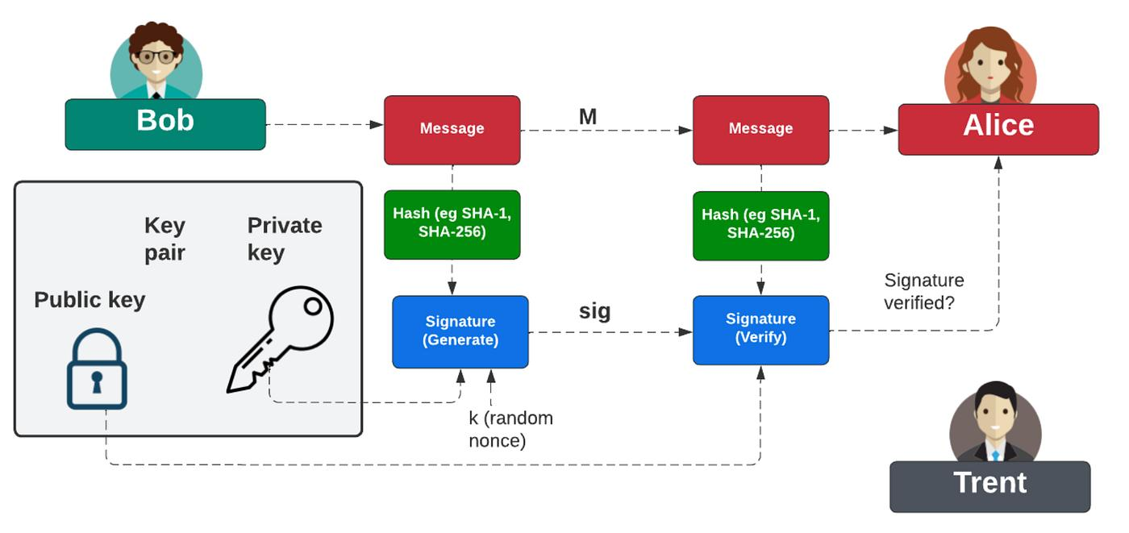
Figure: System workflow
This hybrid approach ensures both efficiency and security. AES provides fast encryption for large files, while RSA ensures secure key distribution.

4. Implementation
The system is implemented using Python and the cryptography library. The project is divided into modular components to enhance readability and maintainability.

4.1 Symmetric Encryption (AES)
AES is used to encrypt and decrypt the file. It is a symmetric encryption algorithm, meaning the same key is used for both encryption and decryption.
In this project:
- A unique AES key is generated for each session
- The file is encrypted into a secure format
- The encrypted file cannot be read without the correct key
AES is chosen due to its high performance and strong security, making it suitable for encrypting large amounts of data.

4.2 Asymmetric Encryption (RSA)
RSA is used to securely encrypt the AES key. It uses a pair of keys:
- Public key (used for encryption)
- Private key (used for decryption)
In this system:
- The AES key is encrypted using the receiver’s public key
- Only the receiver can decrypt it using their private key
This ensures that even if the encrypted file is intercepted, the AES key remains secure.

4.3 Digital Signature
Digital signatures are used to ensure data integrity and authenticity. They verify that the file has not been altered during transmission and confirm the identity of the sender.
The process includes:
- Generating a hash of the encrypted file
- Encrypting the hash using the sender’s private key
- Verifying the signature using the sender’s public key
If the file is modified, the signature verification fails, ensuring strong protection against tampering.

5. Secure Coding Practices
Secure coding practices are essential to prevent vulnerabilities and ensure the reliability of the system. This project follows guidelines from the OWASP Top 10.
Key practices implemented:
- Input Validation:
The system checks whether the file exists before processing to prevent runtime errors.
- Error Handling:
Exception handling mechanisms are used to manage unexpected errors without exposing sensitive information.
- Use of Strong Cryptography:
Industry-standard algorithms such as AES-256 and RSA-2048 are used to ensure robust security.
- Key Management:
Cryptographic keys are stored separately and not hardcoded in the program.
- Data Confidentiality:
Sensitive data is never stored or transmitted in plaintext format.
These practices help in reducing risks such as unauthorized access, data leakage, and system crashes.

6. Testing and Results
The system was tested to ensure that all functionalities work correctly and securely.
Test Cases:
- Encryption and decryption of files
- RSA key encryption and decryption
- Digital signature generation and verification
- Handling invalid or missing files
Results:
- The file was successfully encrypted and decrypted without data loss
- The AES key was securely transmitted using RSA encryption
- Digital signature verification confirmed file integrity
- Any modification to the file resulted in signature verification failure
These results demonstrate that the system effectively ensures confidentiality, integrity, and authenticity.

7. Conclusion
This project successfully demonstrates the implementation of a secure file transfer system using cryptographic techniques and secure coding practices. By combining AES and RSA encryption along with digital signatures, the system provides a comprehensive security solution for data transmission.
The hybrid encryption approach ensures both efficiency and security, making it suitable for real-world applications. Additionally, the application of secure coding practices enhances the reliability and robustness of the system.
Overall, the project highlights the importance of cryptography in modern cybersecurity and provides a practical understanding of how secure systems are designed and implemented.

8. References
1. OWASP – Secure Coding Practices
- Covers secure coding standards and common vulnerabilities
- Useful for your Secure Coding Practices section
https://owasp.org/www-project-top-ten/
2. Python Cryptography Library – Official Documentation
- Used for your implementation (AES, RSA, signatures)
- Explains how the code works
https://cryptography.io/en/latest/
3. Digital Signatures – Cryptographic Signature Systems
- Explains how digital signatures work in detail
- Covers RSA-based signature schemes and security models
- Useful for your Digital Signature section
https://link.springer.com/book/10.1007/978-0-387-27712-7
4. National Institute of Standards and Technology – AES Standard
- Official and most authoritative source for AES
- Defines how AES encryption works
https://nvlpubs.nist.gov/nistpubs/FIPS/NIST.FIPS.197.pdf
5. RSA Laboratories – RSA Cryptography Standard
- Official documentation of RSA algorithm
- Widely used reference for public-key cryptography
https://www.rfc-editor.org/rfc/rfc8017

